# 🏨 Hotel Reservation and Management System

1. 👥 ACTORS
--- 🔹 Guest

* Searches for available rooms
* Makes reservations
* Consults booking history

--- 🔹 Reception Agent

* Registers guests
* Manages reservations
* Handles check-in and check-out

--- 🔹 Hotel Manager

* Monitors hotel activity
* Consults occupancy reports
* Analyzes revenues

--- 🔹 System Administrator

* Manages rooms and room categories
* Maintains database information
* Controls user access

---

2. 📋 BUSINESS RULES

* Each guest is identified by a unique ID.
* A guest may have several reservations.
* A room belongs to one category only.
* A reservation concerns one room and one guest.
* A room cannot be booked twice during the same period.
* A reservation may generate one or several payments.
* Check-in and check-out dates must respect the reservation period.
* A completed reservation creates a stay record.

---

3. 🧾 USER STORIES

--- Guest

* As a guest, I want to reserve a room so that I can stay at the hotel.
* As a guest, I want to view my reservation history so that I can follow my bookings.

--- Reception Agent

* As a reception agent, I want to register a guest so that I can create reservations.
* As a reception agent, I want to update reservation information so that customer requests can be handled.
* As a reception agent, I want to process check-in and check-out operations so that guest stays are tracked.

--- Hotel Manager

* As a hotel manager, I want to access occupancy reports so that I can evaluate room usage.
* As a hotel manager, I want to consult revenue statistics so that I can monitor hotel performance.

--- System Administrator

* As a system administrator, I want to manage room information so that hotel data remains accurate.
* As a system administrator, I want to manage room categories so that accommodations are organized properly.

---

4. 📦 DATA DICTIONARY

--- GUEST

* guest_id
* first_name
* last_name
* email
* phone_number
* address

--- ROOM_CATEGORY

* category_id
* category_name
* nightly_rate

--- ROOM

* room_id
* room_number
* floor
* availability_status
* category_id

--- BOOKING

* booking_id
* booking_date
* arrival_date
* departure_date
* booking_status
* guest_id
* room_id

--- PAYMENT

* payment_id
* payment_amount
* payment_method
* payment_date
* booking_id

--- STAY

* stay_id
* arrival_time
* departure_time
* booking_id

---

5. 🔗 FUNCTIONAL DEPENDENCY GRAPH (GDF)

--- GUEST

guest_id → first_name, last_name, email, phone_number, address

--- ROOM_CATEGORY

category_id → category_name, nightly_rate

--- ROOM

room_id → room_number, floor, availability_status, category_id

--- BOOKING

booking_id → booking_date, arrival_date, departure_date, booking_status, guest_id, room_id

--- PAYMENT

payment_id → payment_amount, payment_method, payment_date, booking_id

--- STAY

stay_id → arrival_time, departure_time, booking_id
6. CONCEPTUAL DATA MODEL (MCD)

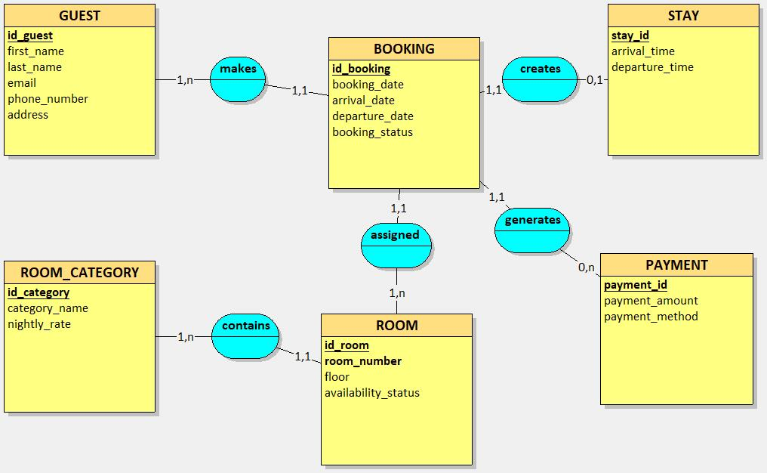

7. LOGICAL DATA MODEL (MLD)

